{
“$schema”: “https:/schema.management.azure.com/schemas/deployement_table.json#",
“content version”: “1.0.0.0” #makes version
“parameters” : {}, #defines input parameters for template
“variables” : {}, 3dynamic variables for parameters for template

“resources”: #resource list
{

#resource A
},
{

resource B
},
“outputs”:{}, #return variables from template
“functions”:[ ],
}

Schema - it defines properties available in template

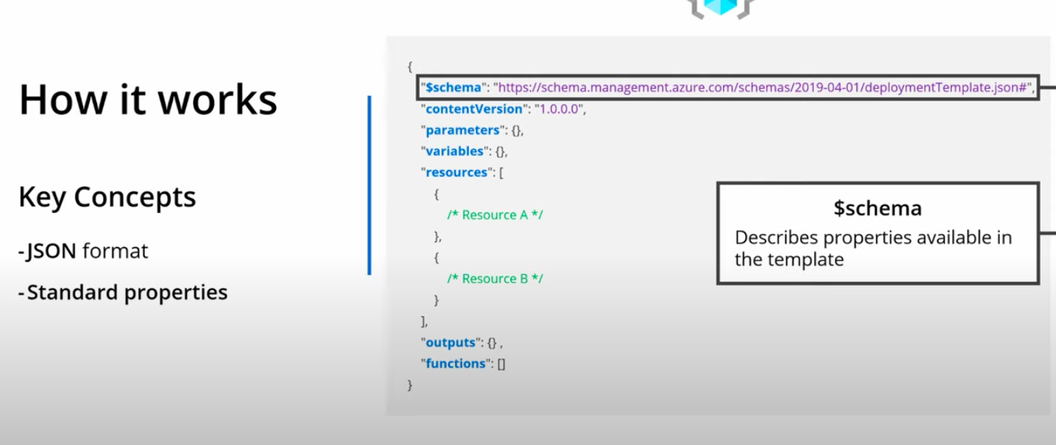

https://github.com/Azure/azure-quickstart-templates —- templates

Microsoft leaning — https://docs.microsoft.com/en-us/learn/paths/deploy-manage-resource-manager-templates/

